 Build your portfolio project (Week 2): MVP Complete

**Challenges**

* **What challenges have you discovered about your project that were not obvious when you did your research?**

That much I have not got any difficult challenges.

* **How have you had to change your plan to adapt to these unearthed challenges?**Time Management: Balancing the project timeline with other ongoing responsibilities and tasks highlighted the need for better time management strategies and more accurate effort estimation for various project phases.
* **Describe any unexpected non-technical challenges?**

Internet Connectivity Issues: In areas with unreliable or limited internet connectivity, team members may face challenges in accessing project management tools, collaboration platforms, or online resources. This can result in delays in communication, difficulty in accessing necessary information, and hindered progress on tasks.

**Collaboration**

I'm collaborating with my staff who assist me when I encounter various challenges on the project.

**Project Updates**

1. Revised Timeline: Adjusting the project timeline to accommodate unexpected delays or additional requirements discovered during the development process. This change ensures that realistic deadlines are set and met, maintaining project credibility and stakeholder trust.
2. Enhanced Feature Set: Adding new features or functionalities to the project scope based on user feedback or emerging market trends. This adjustment improves the project's competitiveness and ensures it meets evolving user needs and expectations.

**Progress**

* On a scale of 1 to 10, I would rate the progress we've made this week as a 8.
* We are measuring our progress based on the completion of planned tasks and milestones outlined in our project timeline, as well as the overall functionality and quality of the project deliverables.
* I have given our team this rating because we have made significant strides in completing key tasks and achieving important milestones. However, there have been some unexpected challenges and delays that have impacted our progress slightly, hence the rating of 7 instead of higher.
* Regarding whether the project will be completed on time as specified in our Project Proposal and MVP definition, I assess that we are still on track to meet the overall project deadline. While there have been some minor delays, we have built in buffer time into our schedule to account for unforeseen obstacles. Additionally, we are continuously monitoring our progress and adjusting our plans as needed to ensure that we stay on schedule and deliver the project within the agreed-upon timeframe.

**Sample Screenshot**

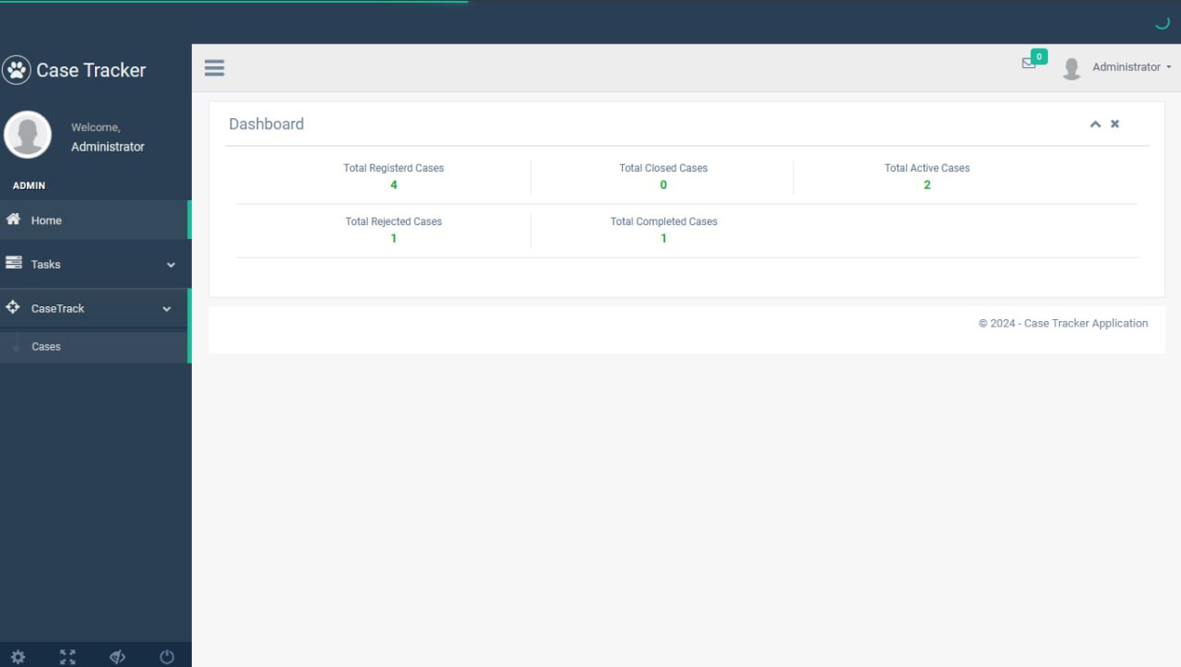

2

